**LAB-6**

**Ubuntu installation and practice on basic networking commands:**

**Aim:**

Study of basic network commands and Network configuration commands.

**Software:**

UTM, Ubuntu

**Procedure:**

OS installation:

OS used: Ubuntu version (20.04)

**Commands used on basic networking:**

1. **Ifconfig:**

You can use the ifconfig commands to assign an address to a network interface and to configure or display the current network interface configuration information.

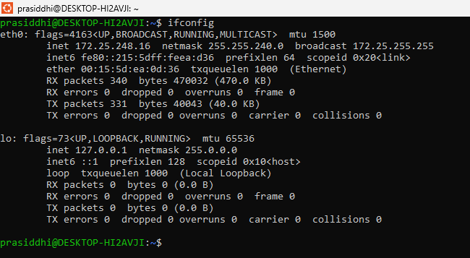

1. **Ping:**

Ping is the primary TCP/IP commands used to troubleshoot connectivity, reachability and name resolution.

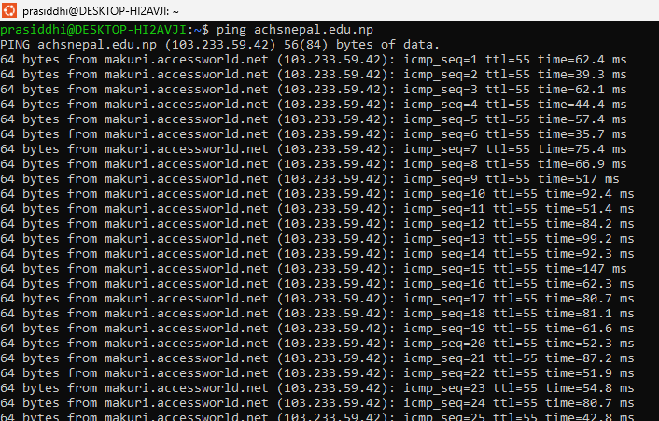

1. **Tracepath:**

The tracepath command in Linux allows to trace the path to the destination path determining MTU along this path using UDP port or any other ports that will not require any superuser permissions.

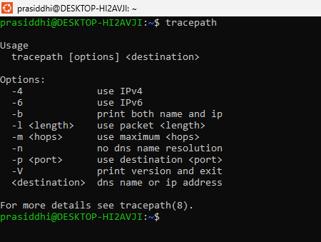

1. **Route:**

The route command allows you to make manual entries into the network routing tables.

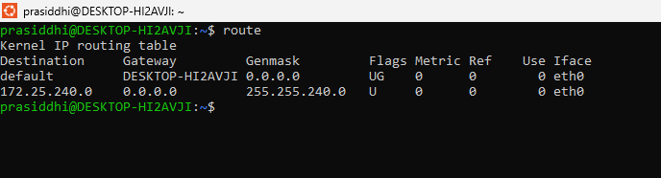

1. **Netstat:**

The netstat command is used to show network status.

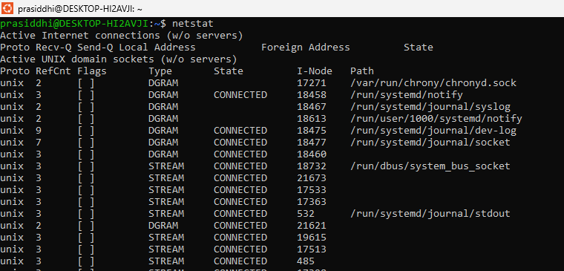

1. **Arp:**

The arp command displays and modifies the Internet-to-adapter address translation tables used by the Address in Networks and communication management.

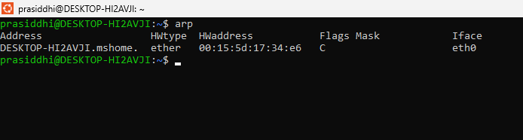

1. **Nslookup:**

nslookup is a network administration command-line tool for querying the Domain Name System (DNS) to obtain the mapping between domain name and IP address, or other DNS records.

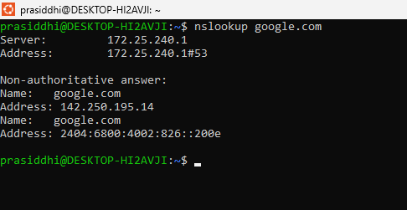

1. **Wireshark:**

Wireshark is a network protocol analyzer, or an application that captures packets from a network connection, such as from your computer to your home office or the internet. Packet is the name given to a discrete unit of data in a typical Ethernet network.

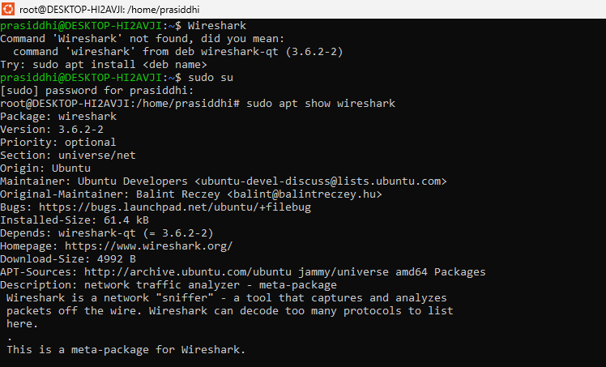

1. **Ifup:**

Here, sudo is used for permissions, -a to work on all devices and v for verbose the output.

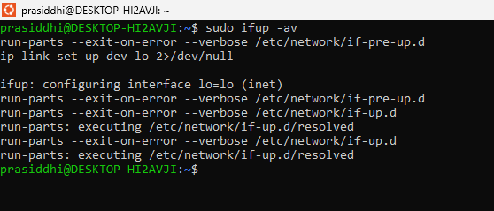

1. **Ifdown:**

The ifdown command disables a network interface, placing it in a state where it cannot transmit or receive data.

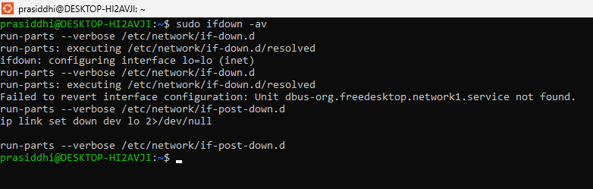

1. **ip**:

Ip shows and manipulates routing, devices, policy routing, and tunnels.

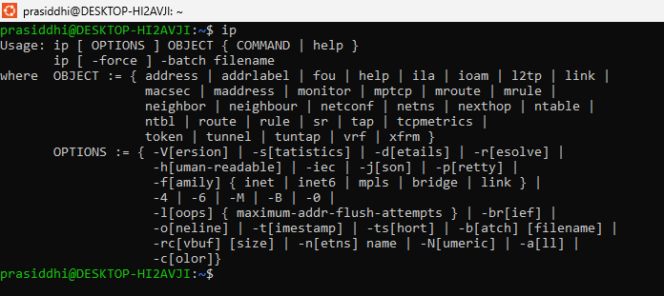

1. **SS:**

SS is a replacement for netstat, providing more detailed and up-to-date information.

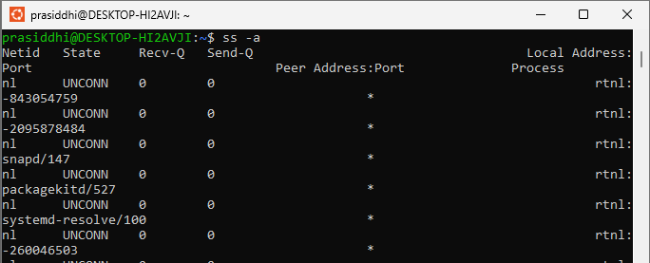

1. **Dig:**

Dig is a tool for querying DNS servers.

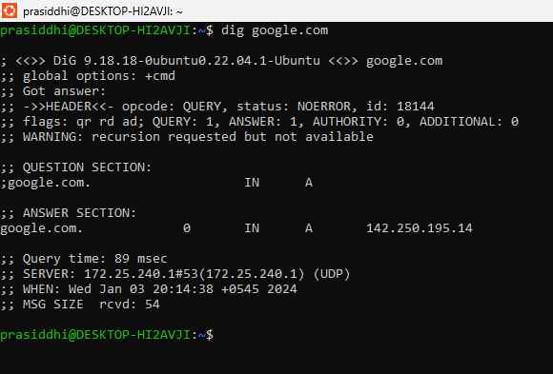

1. **Ip link:**

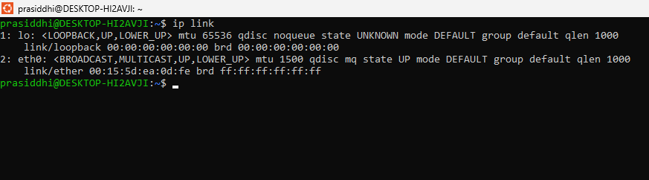

1. **Mtr:**

Mtr command is a combination of ping and the traceroute command. It continuously displays information regarding the packets sent with the ping time of each hop. It is also used to view the network issues.

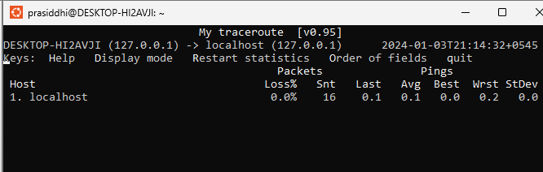

1. **Whois:**

whois command is used to fetch all the information related to a website. You can get all the information about a website including the registration and the owner information.

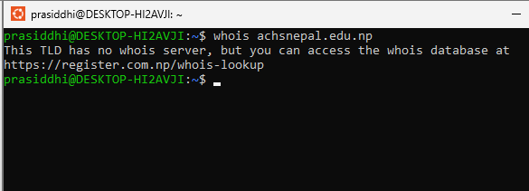

1. **Ifplugstatus:**

ifplugstatus command is used to check if a cable is plugged into the network interface.

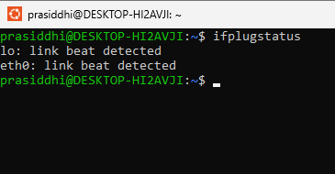

1. **Fping:**

A ping-like program which uses the Internet Control Message Protocol (ICMP) echo request to determine if a target host is responding.

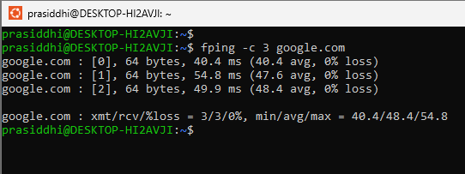

1. **Curl:**

Curl is a tool for making HTTP requests.

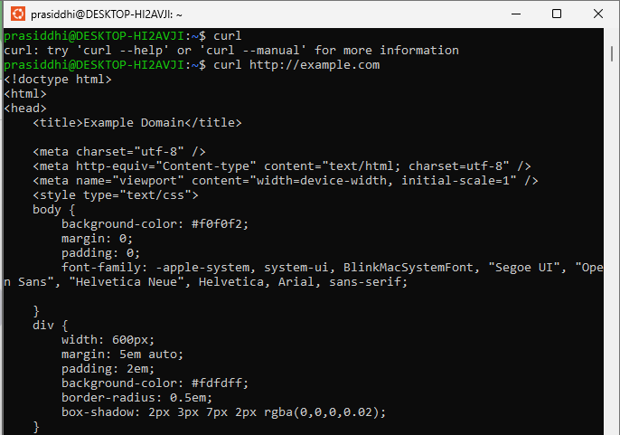

1. **Ethtool:**

Ethtool is used in Queries or controls network driver and hardware settings.

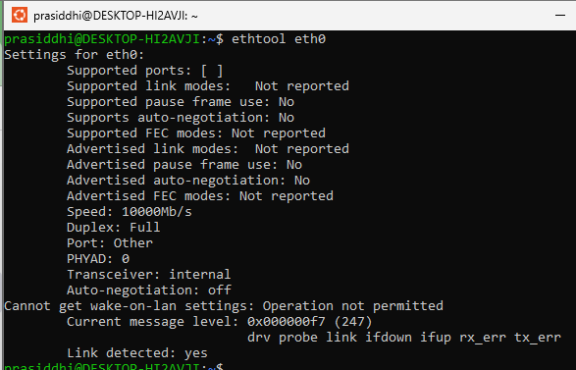

**Conclusion:**

The networking commands in Ubuntu provide a way to manage network interfaces and troubleshoot network connectivity issues. Some commonly used networking commands in Ubuntu include ifconfig, ip, ping, traceroute, netstat, and route.